Government Engineering College, Bhavnagar
Report for SSIP 2.0 Awareness Programme
Name of Department | Information Technology
Target Audience | Branch: Information Technology  Sem: 6
Venue:  Date:  Time | Room No. : 418, EC Building, GEC Bhavnagar  23/06/2023  11:30 A.M
No. Participants | 35
Name of Expert and affiliation | Virendra Barot (Asst. Prof., I.T department, GEC Bhavnagar
Photographs of Programme
1  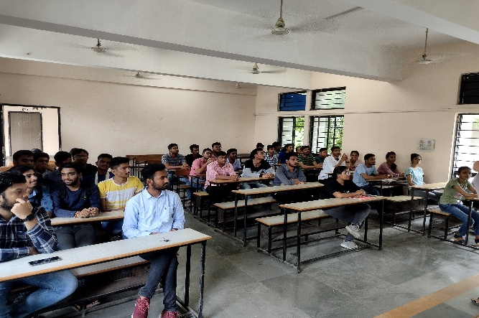 |  | 2  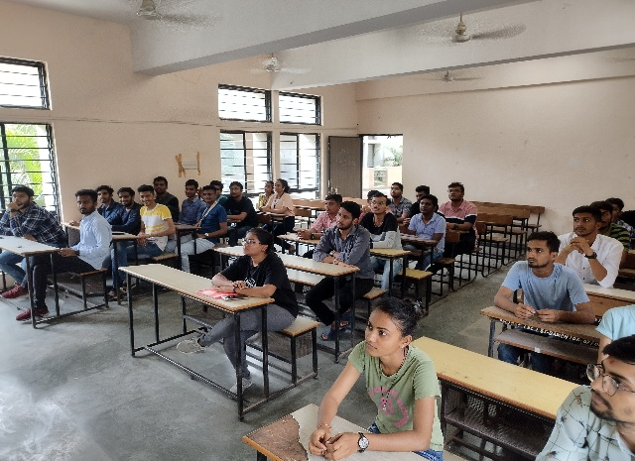
3  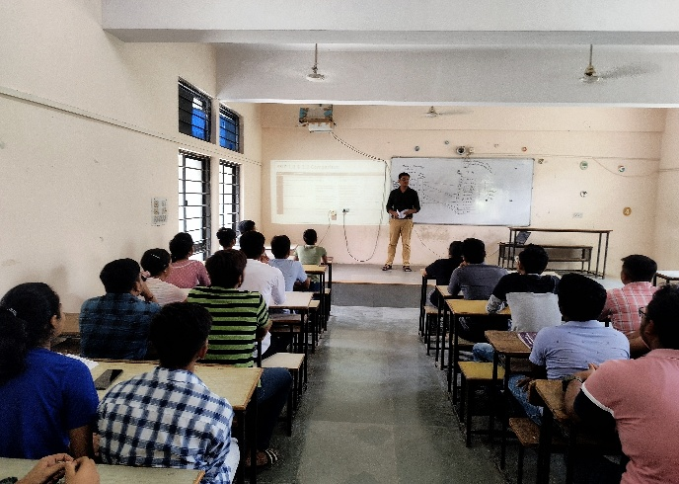 |  | 4

